Screenshots of created collections – using the strapi admin portal to create and save collection types that can store data for me.

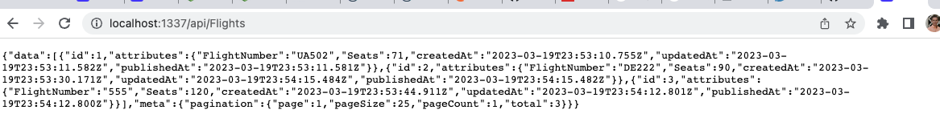

Screenshots of using the browser to directly access the information stored in the content types using the HTTP get request.

Screenshots of using postman “GET” requests to view all data stored in my flights project. Essentially the same as previous just with a GUI and a JSON pretty output instead of raw output in the browser.

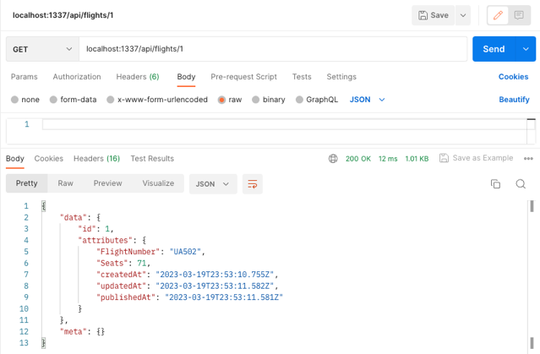

Screenshot of a “GET” request that specifically calls for the flight with ID number 1. These IDs are set by strapi in order that they are published.

Screenshot of postman POST request to add flight. I had trouble initially because I was putting the literal name for airline instead of the strapi ID that was assigned. It initially stated an error because I was referencing an airline that didn’t exist. I just needed to use the ID instead of the name.



Screenshot of newly updated flight. The flights present in the previous screenshot were deleted because I remade the flights collection after I had thought it was a bug that I couldn’t add the other flight in. It therefore deleted the previous ones in an earlier screenshot.

Screenshot of PUT request to update the flight with seats of 60 and American airlines. Needed to add ?populate=\* to show all intact relations in output. I also need to POST American Airlines as a new airline before updating so I didn’t run into the same problem as above.

Screenshot of browser showing the updated flight information

Screenshot of DELETE request and output of deleted entry.

Screenshot of browser query to show deleted entry.

Screenshot of Postman python code grab. You get it on the right side of postman in the </> section.

Screenshot of visual studio code running of the code grabbed in the earlier screenshot. Completed query is at the bottom of the terminal while the top is an error generated because I needed to add [http://](NULL) to the beginning of the URL. It is not done in Postman but is required by python.